**Practical 3 : Write a shell script to display multiplication table of given number.**

echo "My name is Prince Kavar"

echo "My enrollment number is 92410103120"

echo "My class is EC5-C"

echo "Enter a number to display its multiplication table"

read n

if ! [[ "$n" =~ ^[0-9]+$ ]]; then

echo "Invalid input!!"

exit 1

fi

echo "Multiplication table for $n:"

for ((i = 1; i <= 10; i++)); do

echo "$n x $i = $((n * i))"

done

output :

My name is Prince Kavar

My enrollment number is 92410103120

My class is EC5-C

Enter a number to display its multiplication table

10

Multiplication table for 5:

10 x 1 = 10

10 x 2 = 20

10 x 3 = 30

10 x 4 = 40

10 x 5 = 50

10 x 6 = 60

10 x 7 = 70

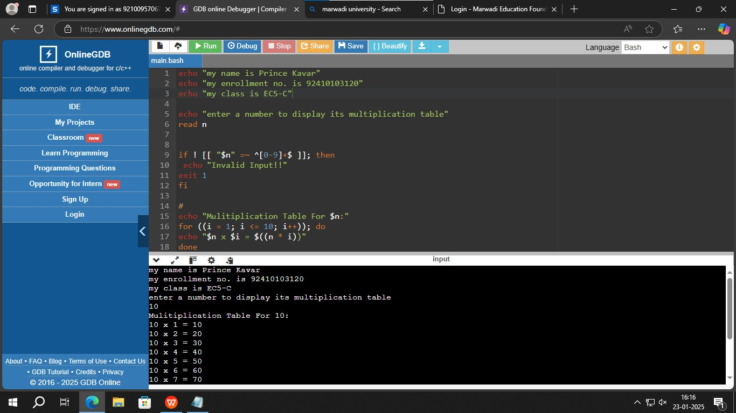

Figure 3.1 : program to print table of given number